Defenders Optimization

Riu Sakaguchi

6/12/2020

Restricted to level 1/wave 1/no upgrades (15 red/5 blue viruses)

Df Sum Sq Mean Sq F value Pr(>F)

LocationCombination 5 2718 543.6 90.273 < 2e-16 ***

MedicineCombination 3 265 88.4 14.672 2.15e-09 ***

LocationCombination:MedicineCombination 15 342 22.8 3.787 1.29e-06 ***

Residuals 1243 7485 6.0

---

Signif. codes: 0 ‘***’ 0.001 ‘**’ 0.01 ‘*’ 0.05 ‘.’ 0.1 ‘ ’ 1

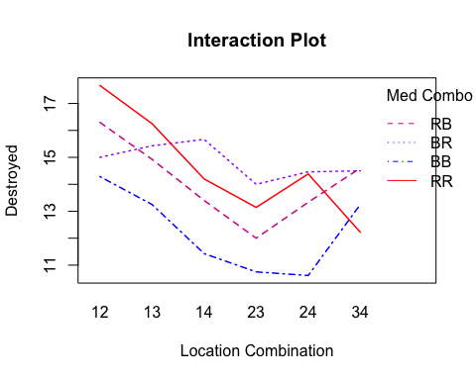

We can win this wave if we use red red and 12 only

This makes sense since turret 1 has the most distance to kill

Why is 12 better than 13 or 14?

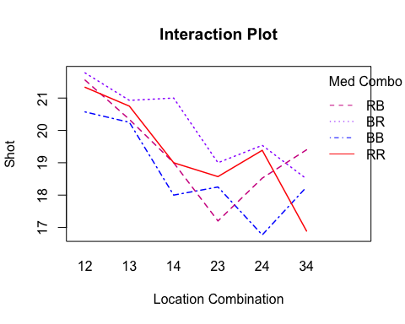

Conduct a t-test to see if there is a difference between 13 and 14

9 tests (for destroyed/shot/percent destroyed for all viruses/red viruses/blue viruses)

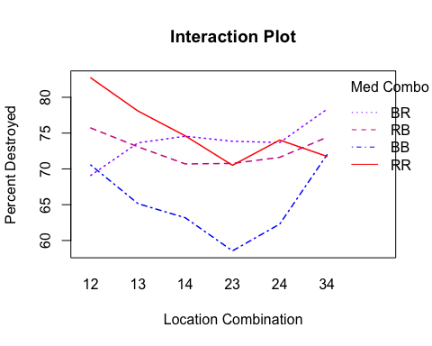

This makes sense since turret 1 has the most distance to kill. It makes sense because turrets 23 and 34 are very close together.

Why is 12 better than 13 or 14?

All data interaction plots faceted by red and blue virus

**Destroyed** BR (12, 13, 14) RR (24, 34) Turrets are too close to each other and since they are effective, many of the shots are not getting in and hence destroyed goes down as well.

**Shot** RR (24, 34) As explained above, turrets are too close to each other and since they are effective, the turret that shoots second won’t get their shot in.

**Percent Destroyed** RB and BR cross between 12 and 13. BB and RR cross at 34 (Sample size could be an issue).

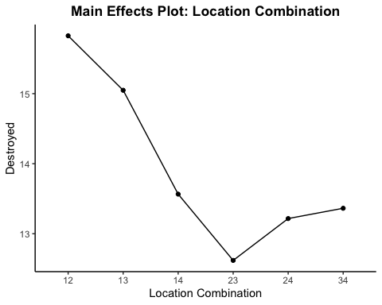

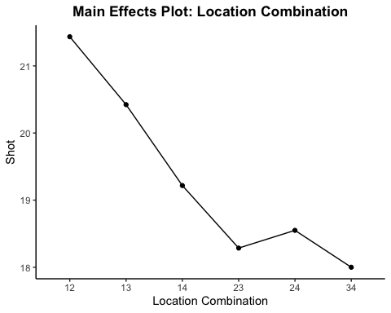

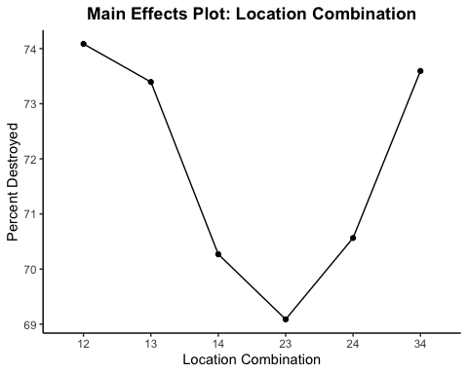

All:

Why is 12 better than 13? (t-test)

Why is 13 better than 14? (t-test)

Percent destroyed: Why is 24 better than 34? (t-test)

* **Three main effects**
* **T-tests right next to each**
* **Interaction plots (3) as well for each virus (6)**
* **9 t-tests**
* **Include game screen shots**

**Destroyed** Higher destroyed when turrets are closer to the entrance makes sense because we also get more shots in. 23 seems to be the worst location combination.

**Shots** Again, we get more shots in when the turrets are placed closer to the entrance, and less as they are placed closer to the exit.

**Percent Destroyed** We see a U shape pattern with higher percentages at locations closest to the entrace and closest to the exit. Could most likley be due to the ratios of medicine combination at each location.

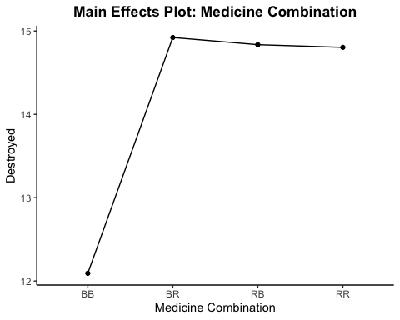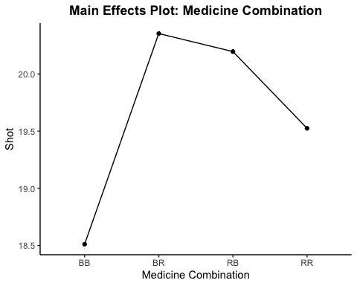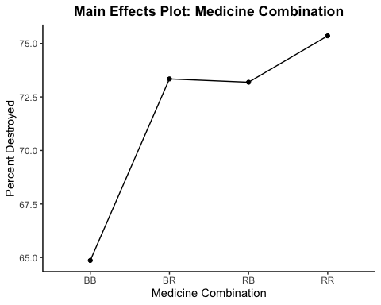

**Destroyed** BB being the worst makes sense because there are more red viruses. The rest seem to be similar in terms of the number of viruses destroyed.

**Shot** Perhaps RR is lower because it is supposed to be the most effective combination, and the second turrent might not be getting in shots. BB being the lowest might be a result of disproportionate location combinations

**Percent Destroyed** This plot makes sense, BB being the lowest, RB and BR being around the same, and RR being the highest.

* Faceted interaction plot for destroyed
  + Is it worthwhile to purchase an upgrade?
  + Should you get one upgrade or two?
  + Should you get a fast or far upgrade, or both?
  + If you get an upgrade, what is the proper placement?
* Include the other two faceted interaction plots
* Include table for both no upgrade and upgrades